LAB EXPERIMENT RECORD
Set 1: Monthly Sales Data

Department | B.Tech-AI&DS
Course Code / Course Name | DSA0602 / Data Handling and Visualization
Experiment | Data Visualization using R
Name | Peram Mahitha
Register Number | 192524136
Date | 29 September 2026
Day | Tuesday

AIM:

To analyze and visualize monthly sales data using R programming by creating line charts, bar charts, and scatter plots, and to develop an interactive dashboard for exploring sales data.

DATASET : MONTHLY SALES

Month | Sales ($)
January | 15000
February | 18000
March | 22000
April | 20000
May | 23000

PROGRAM 1: Create a line chart to visualize the monthly sales

CODE:

month <- c("January", "February", "March", "April", "May") sales <- c(15000, 18000, 22000, 20000, 23000)
data <- data.frame(month, sales)

plot( sales, type = "o", xaxt = "n", xlab = "Month", ylab = "Sales ($)", main = "Monthly Sales" ) axis( 1, at = 1:5, labels = month )

OUTPUT:
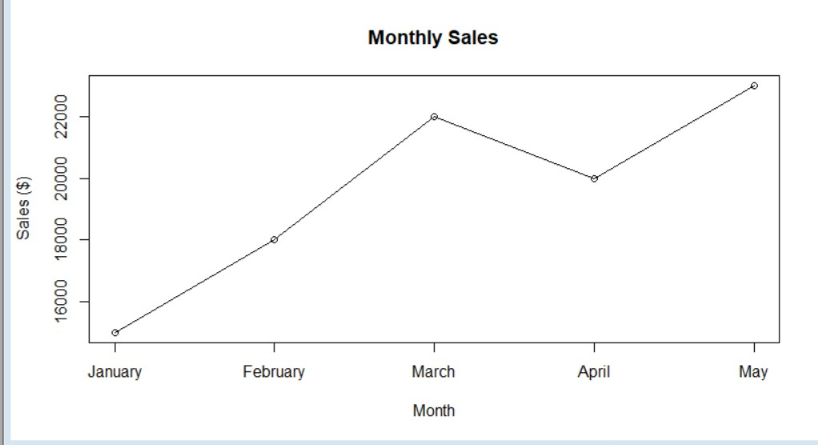

Observation

The line chart represents the monthly sales trend. Sales increase from January to March, decrease slightly in April, and reach the highest value in May.

Program 2: Monthly Sales Bar Chart

CODE:

month <- c("January", "February", "March", "April", "May") sales <- c(15000, 18000, 22000, 20000, 23000)
data <- data.frame(month, sales)

barplot( sales, names.arg = month, xlab = "Month", ylab = "Sales ($)", main = "Monthly Sales", col = "skyblue" )

OUTPUT:
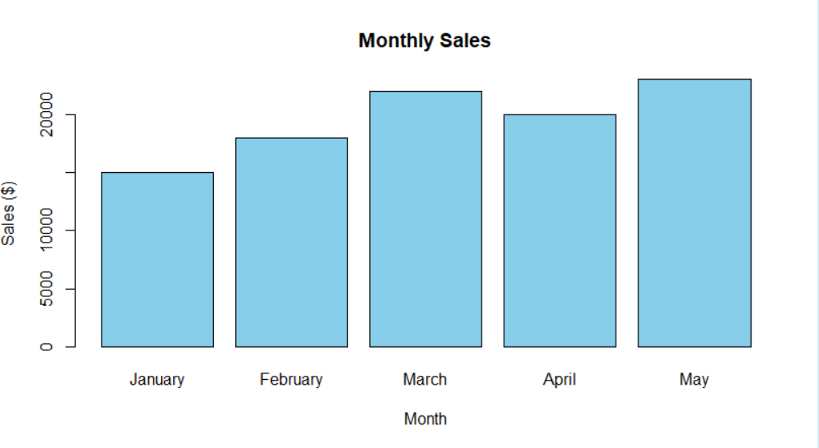

Observation

The bar chart compares the sales values for each month. May has the highest sales, while January has the lowest sales.

Program 3: Advertising Budget vs Monthly Sales

CODE:

month <- c("January", "February", "March", "April", "May") sales <- c(15000, 18000, 22000, 20000, 23000)
advertising_budget <- c(5000, 6000, 7000, 6500, 8000) data <- data.frame( month, sales, advertising_budget )
plot( data$advertising_budget, data$sales, xlab = "Advertising Budget ($)", ylab = "Monthly Sales ($)", main = "Advertising Budget vs Monthly Sales", pch = 19 )
abline( lm(sales ~ advertising_budget, data = data), lwd = 2 )

OUTPUT:
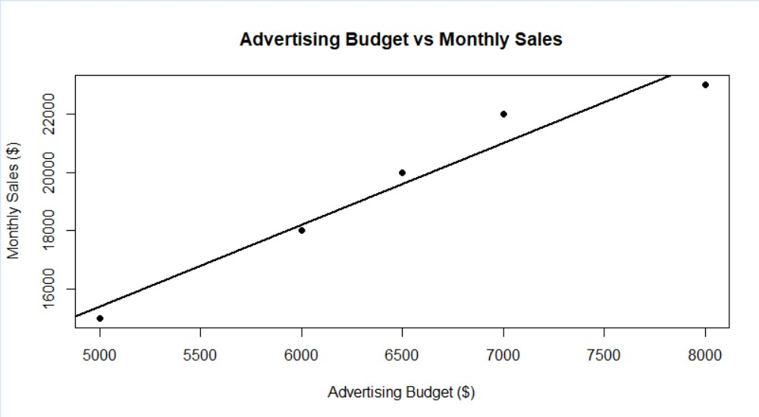

Observation

The scatter plot shows the relationship between advertising budget and monthly sales. The direction of the plotted points and regression line can be used to identify whether the relationship is positive or negative.

Program 4: Interactive Sales Dashboard

CODE:

library(shiny)

month <- c("January", "February", "March", "April", "May") sales <- c(15000, 18000, 22000, 20000, 23000)
data <- data.frame(month, sales) ui <- fluidPage(
titlePanel("Monthly Sales Dashboard"), sidebarLayout(
sidebarPanel( sliderInput( "range",
"Select Months:", min = 1,
max = 5,
value = c(1, 5), step = 1
)
),

mainPanel( plotOutput("lineChart"), plotOutput("barChart")
)

) )

server <- function(input, output) { filteredData <- reactive({ data[input$range[1]:input$range[2], ]

})

output$lineChart <- renderPlot({ d <- filteredData()
plot( d$sales, type = "o",
xaxt = "n",
xlab = "Month", ylab = "Sales ($)",
main = "Monthly Sales - Line Chart"
)

axis(

1,
at = 1:nrow(d), labels = d$month
)

})

output$barChart <- renderPlot({

d <- filteredData()

barplot( d$sales,
names.arg = d$month,
xlab = "Month",
ylab = "Sales ($)", main = "Monthly Sales - Bar Chart"
)

}) }

shinyApp(ui = ui, server = server)

OUTPUT:
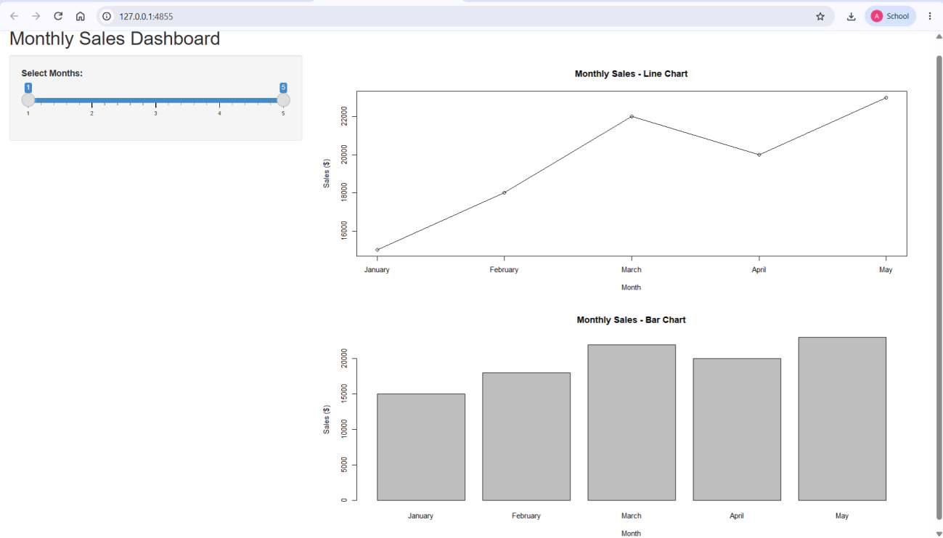

Observation

The dashboard displays the monthly sales using both a line chart and a bar chart. The month-selection slider allows the user to interactively select the required range of months.

Procedure:

- Open R programming environment.
- Create the required dataset using vectors.
- Convert the vectors into a data frame.
- Analyze the monthly sales data.
- Create a line chart using plot().
- Create a bar chart using barplot().
- Create a scatter plot to examine the relationship between advertising budget and sales.
- Create an interactive dashboard using the Shiny package.
- Execute each program separately.
- Observe and interpret the generated visualizations.

Result :

Thus, the monthly sales data was successfully analyzed and visualized using R programming through line charts, bar charts, scatter plots, and an interactive dashboard.

KEY R FUNCTIONS USED

R Function | Purpose
c() | Creates a vector
data.frame() | Creates a data frame
print() | Displays data/output
plot() | Creates line/scatter plots
axis() | Adds/customizes an axis
barplot() | Creates a bar chart
lm() | Creates a linear regression model
abline() | Adds a regression line
library() | Loads a package
install.packages() | Installs an R package
fluidPage() | Creates Shiny UI
titlePanel() | Adds dashboard title
sidebarLayout() | Creates sidebar + main area
sliderInput() | Creates an interactive slider
plotOutput() | Creates plot output area
renderPlot() | Generates a plot in Shiny
reactive() | Creates reactive data
shinyApp() | Runs the Shiny application

